Comparative analysis on Computing Disparity map

Chitra Suresh
Dept.of Electronics Engineering
(D.Y.Patil’RAIT)
Dept.of Electronics &Telecommunication Engineering (D.Y.Patil’RAIT)
Navi Mumbai, India chitra.suresh@rait.ac.in
Kushal R. Tuckley
Dept. of Electrical Engineering
(IIT Bombay )
AGV Systems Pvt.Ltd
Mumbai, India
kushal@ee.iitb.ac.in

Abstract— The stereoscopic images or stereo pair image consists of two images of the same scene taken slightly horizontally separated points from the left view and the right view. The disparity for stereoscopic image is horizontal distance between two matching pixel. The disparity map is horizontal pixel distance for each pixel coordinates. In this paper we computed disparity map using Minimum Index method, Matlab in build function method and Minimum sum Belief propagation method. The computing disparity map at different disparity levels is explored. The computational error estimation and runtime analysis is also performed at disparity level sixteen.
Keywords—Stereo Image, Disparity, Disparity Map

Introduction
The stereoscopic images or stereo pair image consists of two images of the same scene taken slightly horizontally separated points from the left view and the right view. The objects near the camera will represent more to the right in left image and more left in the right image in stereoscopic or stereo pair images due to parallax effect. The horizontal displacement of an object left and right view depends on the distance from the object to the camera view points. The disparity for stereoscopic image is horizontal distance between two matching pixel and horizontal pixel distance for each pixel coordinates is Disparity map. The Depth map or Disparity map is a gray scale image which is highly compressed. The Depth map or Disparity map shows distance rather than texture. If shift of pixel between right and left stereo image is more than object looks darker which is located far away from camera and if shift is less than object is bright i.e. object close to the camera.
There are various methods to find Disparity map or Depth map which is Area-based, Feature- based and Global based methods. The Area and Feature based methods are based on intensity profile. The constrains in Area- based algorithm is to find the optimal size of the window. The Feature-based algorithms are restricted to using only specific feature, that only yield sparse disparity maps. The Global methods are based on Bayesian approach to finds disparity as an energy minimization problem.
Some Applications of disparity map are:
- Disparity map is used to reconstruct 3D model sequences which can be used either for information transfer or for entertainment.
- In Robotic application disparity map is used to navigate and object recognition where to separate occluded region in image components
- Scientific application of Disparity Map are to extracts information from aerial surveys and for calculation of contour maps
In this paper we computed disparity map using three different methods which are Minimum Index Method ,MATLAB in build function ’Disparity Map’ from computer vision tool box and third method Minimum Sum Belief propagation. The error estimation shows that disparity map using Minimum Index method at disparity level sixteen is better than other two methods. The subjective analysis with respect to ground truth images shows that disparity map at disparity level sixty four is using Minimum Sum Belief propagation is more compensable to other two methods. This paper is organized as follows: Literature survey is given in section II, overview of method used is explained in section III, experimental results shown in section IV and its discussion elaborated in section V and conclusion is given in section VI

Literature Survey
The method used in [1] “Adaptive support –weight approach for correspondence search” is area based local method to generate depth map or disparity map. The proposed method is based on Gestalt grouping in which support weight is based on similarity and proximity and is proportional to the strength of the grouping. In this method these two values expressed as a single value in an integrated manner. The group of similarity is calculated by means of Euclidean distance whereas group of proximity is by means of Laplacian Kernel. The weight adoptive method computationally takes more time than other methods.
The method used in [2] “A New Approach for Disparity Map Estimation from stereo Image Sequences using Hybrid Segmentation Algorithm” is feature based local method to generate depth map or disparity map. The estimation of Disparity map is by using K-mean square algorithm and hybrid segmentation algorithm. The K means clustering algorithm is used to group the objects based on some criteria. K is a positive integer. The criteria for grouping is by minimizing the distance between data and cluster centroid .Initial set of K, virtual points in the data space randomly selected and every point if data set is assigned nearest centroid. The position of centroid is updated by means of the data points assigned to the cluster. The algorithm is stopped when minimum shift is below threshold. The segmentation algorithm extracts feature by Scale Invariant Feature Transform (SIFT) and Sum of Absolute Difference (SAD).The proposed algorithm is complex and computation time is more.
The method used in [3] “A Comparative Study of Energy Minimization Methods for Markov Random Fields” is global based method to generate depth map or disparity map. The method used is energy minimization problem on rectangular grid of pixels where energy expressed as data term and smoothness term. The method used is complex and computation time is more.
The method used [7] in “A Region Based Stereo Matching Algorithm Using Cooperative Optimization ”is region based stereo matching algorithm using cooperative optimization. In cooperative optimization regions are selected using color statistics and constrains on smoothness and occlusion between adjacent regions. The first step in Cooperative Optimization is color based segmentation to partition in to regions according to homogeneous color for reference image. The second step is using window based method to find initial disparity estimate for each pixel and plane fitting technique is used to obtain parameters of disparity plane corresponding to each image region. Final step is that under the framework of inter-regional cooperative optimization, the disparity plane parameters of all regions are iteratively optimized by a local optimization procedure until a reasonable disparity map is obtained
In research paper “Efficient Loopy Belief Propagation using the Four Color Theorem”[12] shows that to reduce the computational complexity of belief propagation by applying the Four Color Theorem (FCT) to limit the 10 maximum number of labels in the underlying image segmentation to at most four. This provides substantial speed improvements for large inputs, and this for a variety of vision problems, while maintaining competitive result quality.
The Four-Color Theorem based on the max-product belief propagation technique can be used in early computer vision for solving MRF problems where an energy is to be minimized. Methods used in this research yield results that are comparable with other methods, but improve either the speed for large images and/or large label sets (the case of image segmentation, stereo matching and optical flow), or both the performance and speed (the case of image denoising).
The Four Color Theorem principle is difficult to apply in cases where the label set is discrete and no natural order/relation between them can be inferred. This is the case for stereo matching and optical flow, where the disparity cost function takes discrete, unrelated values. This causes slower convergence, but is compensated by the low time complexity of the methods, independent of the number of labels. Thus, the proposed methods perform faster than the standard methods considered here, at least for large inputs
In research paper “Comparison of graph cuts with BP for stereo using identical MRF parameters”[6]the disparity image can be achieved by modeling Markov Random Field and by using optimization algorithm such as Graph cut and Belief Propagation. These two algorithms allow fast and approximate solution to MRF which are powerful tools for modeling vision problems. So one system can improvement over the other is particularly to its choice of an inference algorithm.

OVER VIEW OF METHOD USED
The first method used to compute disparity map is using MATLAB in build function “Disparitymap” in computer vision tool box. The algorithm used in matlab in build function is Semi Global Block matching algorithm [4] .The sum of absolute difference is used to compare each block of pixel in stereo image and Semi Global Block matching algorithm enforces same disparity to neighboring blocks. The semi global block matching algorithm measure the contrast of stereo image by using sobel filter. The semi global block matching algorithm finds the disparity for each pixel in left stereo image.
The second method used to compute disparity map is minimum index method. In Minimum indexed method, Minimum sum of absolute difference function is used. The intensity value or pixel value is shifted by disparity range or level either in left stereo image or to right stereo image. In proposed indexed method right stereo image is shifted by disparity range or level. When minimum occurs in shifted values which is considered as disparity. The stereo pair or stereo images are rectified images so that horizontal scanning is performed on these images. The mathematical description of proposed method is given below.
The general function used as cost function for stereo pair image to find disparity map is:
Cost function (C _{f}) = |I_{L} -I_{R} | (1) Where I_{L} is left stereo image, I_{R} is right stereo image
In Minimum Index method Minimum sum of Absolute Difference (SAD) is used.
Cost function (C_{f1}) = min |I_{L} -I_{R-d} | (2)
Where d is disparity range or level:
The disparity value is decided when, minimum difference in pixel values is observed
f (z) =min (C_{f1}) for 1<z<d (3) where z is minimum disparity value.
The third method used to compute disparity map is Global method. In global method Markov Random Field formulation is used to find energy minimization function. The optimization algorithm is used to find energy minimization in MRF formulation. In proposed third method minimum sum belief propagation is used to find disparity map. The energy function is:
E (f) = ∑ _{i ϵI} D _{i} (f _{i}) + ∑ _{i,j ϵN} S _{i,j} (f _{i ,}f _{j} ) (4) Where D is data cost function :S is smoothness cost function i is pixel index : j is neighboring index.

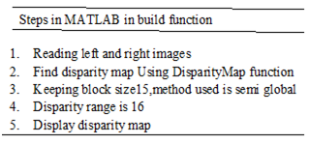
Figure1 Trace for MATLAB in build function
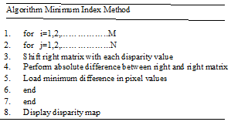

Figure2: Pseudo code for Minimum Index Method

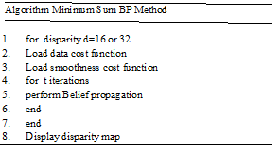

Figure 3: Pseudo code for Minimum Sum BP Method

EXPERIMENTAL RESULTS
The test stereo images used for experimental analysis are from Middlebury computer vision web site (vision.middlebury.edu). The ground truth image for each test stereo image is used for comparing performance of disparity map. [13].The software used for programming is MATLAB version 15.
The disparity map is computed using minimum index method, MATLAB in build function “DisparityMap” and using Minimum sum Belief Propagation method for disparity level 16.The different disparity map for various test stereo images for all 3 methods with input stereo image and ground truth are shown in figure3
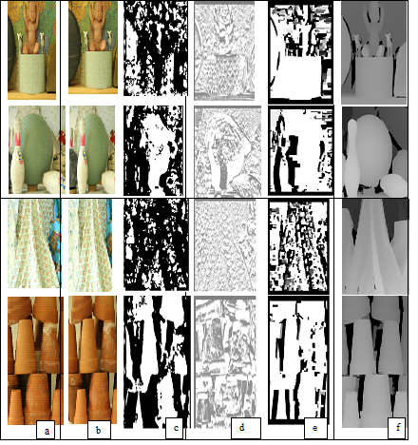

(a)Left Image (b) Right Image (c) In build MATLAB function method(d) Minimum Index Method(e) Minimum Sum Method (f) Ground truth

Figure 3: Disparity map using various methods with input stereo image and ground truth
The computational estimation mean square error (MSE) is calculated with respect to ground truth for all computed disparity map. The estimated MSE per total number of pixel are shown in table1
Table1: Error Estimation for all methods for disparity level 16 for all test stereo images
Stereo Image | Matlab in build function Method  (MSE per pixel) | Minimum Index Method  (MSE per pixel) | Minimum Sum Method  (MSE per pixel)
Baby | 0.1 | 0.013 | 0.10
Bowling | 0.12 | 0.019 | 0.11
Cloth | 0.13 | 0.014 | 0.98
Pot | 0.11 | 0.019 | 0.12

The system used to measure run time for all three methods for all test stereo images is Intel(R) Core(TM) i5-4200M CPU @2.5GH.The graphical representation of run time is shown in figure 3.

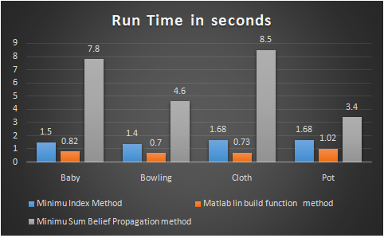

Figure 4: Bar graph for runtime for disparity level 16
In second method of analysis disparity level is increased to sixty four for all three methods. The computed disparity map for all test stereo images are shown in figure 5.

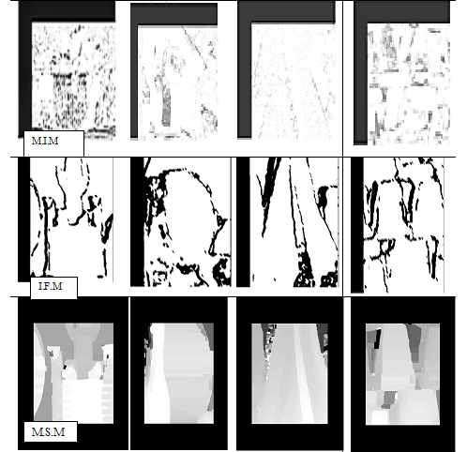
MIN: Minimum Index Method IFM: In build function Method MSM: Minimum sum Method:
Figure 5: Disparity map for different test stereo images for disparity level 64

DISCUSSION
In first analysis, disparity map is computed at disparity level16 using Minimum Index,”DisparityMap” MATLAB in build function and Minimum Sum Belief Propagation methods. The computational error estimation i.e. Mean Square Error per total number of pixels is less for all test stereo image using Minimum Index than,”DisparityMap” function and Minimum Sum Belief Propagation.
The run time analysis shows that for all test stereo images at disparity level 16 using matlab inbuilt function method takes less time where as the run time using minimum index method takes twice as compare to matlab in build function method. The time taken to run minimum sum belief propagation is more compare to other two methods.
In second analysis disparity level is increased to 64 for all methods. The performance analysis is subjectively by human perception with respect to ground reality image, which shows that disparity map computed using Minimum Sum Belief Propagation is better than Minimum Index than ,”DisparityMap” function. When disparity level is increased to 64 MTLAB in build function detects the edges of the objects in disparity map. The constrain in minimum Index is that when disparity level is increased to 64 is that to find minimum index value in disparity map

CONCLUSION
The disparity map is computed using Minimum Index method, MATLAB in build function from computer vision tool box and Minimum Sum Belief Propagation method at different disparity levels. The computational error estimation and subjective analysis by human perception shows that minimum index method is better at disparity level sixteen than other two methods.
The second subjective analysis by human perception with respect to ground truth shows that sharpness of disparity map computed by Minimum Sum Belief Propagation method at disparity level sixty four is better than other two methods.
The further study can be done to improve performance in minimum index method using smoothing filters. In detail study of minimum sum belief propagation is required as future study
References

- L. kuk-Jin Yoon, In Sokweon, “Adaptive support -weight approach for correspondence search,” IEEE Trans- actions on pattern analysis and machine Intelligence Vol. 28,no.4,April 2006,pp 650-651.
- Patrik Kamencay,Martina Zachariasova,Martin Brezman,Roman Jarina,Robert Hudec,Miroslav Benco,Slavomir Matuska, ”A New Approach for Disparity Map Estimation from stereo Image Sequences using Hybrid Segmentation Algorithm”, International Journal of Modern Engineering Research,Vol.2,Issue 5,Sep-Oct 2012 ,pp3201-3206
- R. Szeliski, R. Zabih, D. Scharstein, O. Veksler, V. Kolmogorov, A. Agarwala, M.F. Tappen and C. Rother, ”A Comparative Study of Energy Minimization Methods for Markov Random Fields”, IEEE Trans. Pattern Anal. Mach. Intell., vol. 6, no. 30, (2008), pp. 1068-1080.
- Http://in.mathworks.com/help/vision/ref/disparity.html
- Brad Hiebert-Treuer,SarriAl Nashashibi and Daniel Scharstein,Middlebury stereo vision pages, http://Vision.middlebury.edu
- Tappen,M.F.andFreeman,W.T.,“Comparision of graphcuts with BP for stereo using identical MRF parameters”,In IEEE International conference on computer vision
- Zeng-Fu Wang and Zhi-Gang Zheng, "A region based stereo matching algorithm using cooperative optimization," 2008 IEEE Conference on Computer Vision and Pattern Recognition, Anchorage, AK,2008,pp.1-8.doi: 10.1109/CVPR.2008.4587456
- M. Z. Brown, D. Burschka, and G. D. Hager, "Advances in computational stereo," IEEE Transactions on Pattern Analysis and Machine Intelligence, vol. 25, no. 8, pp. 993-1008, 2003.
- KomalD.Bhavsar, Virendra Singh,” Analysis of Disparity Map for stereo Matching Algorithm”, International Journal for scientific Research & Development,Vol.1,IIsue 11,2014,ISSN(online):2320613
- W. D. Hu, K. Zhang, L. F. Sun, J. Y. Li, Y. J. Li and S. Q. Yang, “Virtual Support Window for Adaptive-weight Stereo Matching”, IEEE Visual Communications and Image Processing (VCIP), (2011) November 6-9, pp. 1-4, Tainan, Taiwan.
- Dan Yuan, “Understanding Belief Propagation And Its Applicatons ”, Department Of Computer Engineering ,University Of California.
- Timofte R., Van Gool L. (2013) Efficient Loopy Belief Propagation Using the Four Color Theorem. In: Farinella G., Battiato S., Cipolla R. (eds) Advanced Topics in Computer Vision. Advances in Computer Vision and Pattern Recognition. Springer, London https://doi.org/10.1007/978-1-4471-5520-1_11
- Colin Doutre and PanosNasiopoulos,” A Stereo matching Datacost Robust to Blurring”,IEEE 17th International conference on Image Processing, September 26-29, 2010,Hong Kong
- R. Klette and S. Morales, "Prediction Error Evaluation of Various Stereo Matching Algorithms on Long Stereo Sequences," 2009.
- https://github.com/daviddoria/Tutorials/blob/master/BeliefPropagation/- BeliefPropagation.pdf?raw=true
- https://vision.middlebury.edu/stereo/data
- LiCheng,TerryCaellu ,”Bayesian Stereo matching” ,Computer vision and Image understanding http://www.elsevier.com/locate/eviu
- Y. Boykov, O. Veksler and R. Zabih,“Markov Random Fields with Efficient Approximations, Proc. IEEE Int. Conf. Pattern Analysis and Machine Intelligence, (1998) June 23-25, pp. 648-655, Santa Barbara, CA, USA.
- SomonHermann,ReinhardKlette“ The Naked Truth about cost functions for stereo matching”,http://www.mi.auckland.ac.nz/EISATS
- G.Gerig,www.Sci.Utah.edu/gerig/CS6320-S2013/…../CS6320-cv-F2012-Rectification.pdf

